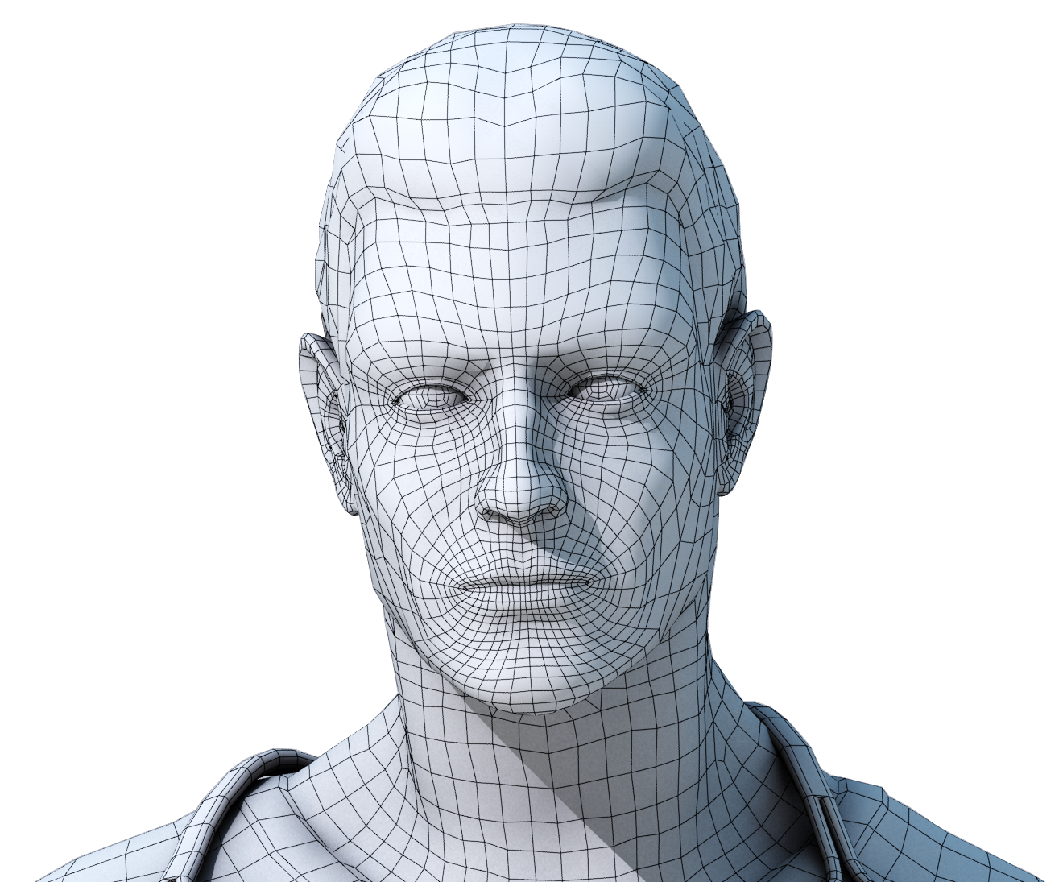

# Face Recognition Attendance System

**M.Ihsan**

**20117398**

**CL/BScSD/13/38**



Cardiff Metropolitan University

**Face Recognition Attendance System**

Submitted in April 2018

By

**Ihsan Affar**

(Student ID - [st20117398] – [BSc SD/13/38)

*This dissertation is submitted in partial fulfilment*

*Of the requirements for the degree of*

**BSc (Hons) Software Engineering**

**DECLARATION**

This work is being submitted in partial fulfilment of the requirements for the degree of

………………………………………………………………………………………….and has not previously been accepted in substance for any degree and is not being concurrently submitted in candidature for any degree.

Signed -  ............................................................ (Candidate)

Date -  ...................................

**SUPERVISOR’S DECLARATION STATEMENT**

Student Name – Ihsan Affar

Supervisor’s Name - Mr. Priyanga Siriwardana

I acknowledge that the above named student has regularly attended the meeting, and actively engaged in the dissertation supervision process.

Signed - ……………………………………………. (Supervisor)

Date    - …………………......

**Coursework Cover Sheet**

|  |  |  |  |  |  |
| --- | --- | --- | --- | --- | --- |
| **Student Details ( Student should fill the content)** | | | | | |
| Name | | M.Ihsan | | | |
| Student ID | | st20117398 | | | |
| **Scheduled unit details** | | | | | |
| Unit code | | CIS6002 | | | |
| Unit title | | Software Engineering Dissertation Project | | | |
| Unit enrolment details | | Year | | 3 | |
| Study period | | 2016-2017 | |
| Lecturer | | Mr. Shamir Dias | | | |
| Mode of delivery | | Full Time | | | |
| **Assignment Details** | | | | | |
| Nature of the Assessment | |  | | | |
| Topic of the Case Study | |  | | | |
| Learning Outcomes covered | |  | | | |
| Word count | |  | | | |
| Due date / Time | |  | | | |
| Extension granted? | | Yes | No | Extension Date |  |
| Is this a resubmission? | | Yes | No | Resubmission Date |  |
| **Declaration** | | | | | |
| I certify that the attached material is my original work. No other person’s work or ideas have been used without acknowledgement. Except where I have clearly stated that I have used some of this material elsewhere, I have not presented it for examination / assessment in any other course or unit at this or any other institution | | | | | |
| Name/Signature | |  | | Date |  |
| **Submission** | | | | | |
| Return to: | |  | | | |
| **Result** | | | | | |
| Marks by 1st Assessor |  | Signature of the 1st Assessor | |  | **Agreed Mark** |
| Marks by2nd Assessor |  | Signature of the 2nd Assessor | |  |
| **Comments on the Agreed Mark.** | | | | | |
| **For Office use only (hard copy assignments)** | | | | | |
| Receipt date |  | Received by | |  | |

|  |  |  |  |  |  |  |  |  |  |
| --- | --- | --- | --- | --- | --- | --- | --- | --- | --- |
| **STUDENT NAME:** | | | | | | | | **STUDENT NUMBER:** | |
| **Module Number & Title**: | | | | | | | | **Semester:** | |
| **Assignment Type & Title:** | | | | | | | | | |
| **For student use: *Critical feedback on the individual progression towards achieving the assignment outcomes*** | | | | | | | | | |
|  | | | | | | | | | |
| **For the Assessors’  feedback**  **Indicate the Task number strength and Weaknesses and the marks for each task** | | | | | | | | | |
| **Task No/Question No** | **Strengths  (1st Assessor)** | | | | | **Weaknesses (1st Assessor)** | | | |
| **Task No / Question No** | **Strengths (2nd Assessor)** | | | | | **Weaknesses (2nd Assessor)** | | | |
| **Areas for future improvement** | | | | | | | | | |
| **Comments by 1st Assessor** | | | | | **Comments by  2nd Assessor** | | | | |
| **Marks** | | | | | | | | | |
| **Task /Question No** | **Marks by 1st Assessor** | **Marks by 2nd Assessor** | | **Marks by IV (if any)** | | | **IV comments (If Any)** | | |
|  |  |  | |  | | |  | | |
|  |  |  | |  | | |
|  |  |  | |  | | |
| **Total Marks** |  |  | |  | | |
| **Name and the Signature of the 1st Assessor** | | |  | | | | **Date:** | |  |
| **Name & Signature of the 2ndAssessor :** | | |  | | | | **Date :** | |  |
| **Name & Signature of the IV: (If any)** | | |  | | | | **Date :** | |  |

Contents

[Face Recognition Attendance System 1](#_Toc510106074)

[Abstract 12](#_Toc510106075)

[Chapter 01 12](#_Toc510106076)

[Introduction 12](#_Toc510106077)

[1.1 Problem Statement 14](#_Toc510106078)

[1.2 Proposed Solution 15](#_Toc510106079)

[1.3 Literature Review 16](#_Toc510106080)

[1.4 Feasibility Study 21](#_Toc510106081)

[Technical Feasibility 21](#_Toc510106082)

[Scope Feasibility 22](#_Toc510106083)

[Time Feasibility 22](#_Toc510106084)

[1.5 Design Overview 23](#_Toc510106085)

[Development Method 23](#_Toc510106086)

[1.6 Work Breakdown Structure 23](#_Toc510106087)

[1.7 Resource allocation 24](#_Toc510106088)

[1.8 Milestone Plan 25](#_Toc510106089)

[1.9 Cost Plan 26](#_Toc510106090)

[Webcam to capture the image 26](#_Toc510106091)

[Desktop Computer 26](#_Toc510106092)

[Server 27](#_Toc510106093)

[Resources Required 27](#_Toc510106094)

[Expected Output and Outcome 29](#_Toc510106095)

[Chapter 2 Background of the Study 30](#_Toc510106096)

[2.1 What is it? 30](#_Toc510106097)

[2.2.Why is it Important? 30](#_Toc510106098)

[2.3. List of User Requirements 31](#_Toc510106099)

[2.4. The Current System 31](#_Toc510106100)

[2.5. Drawbacks of the Current System 32](#_Toc510106101)

[2.6. Explanation of the Proposed System 32](#_Toc510106102)

[Requirement Gathering 33](#_Toc510106103)

[Questionnaire 34](#_Toc510106104)

[3.3. The Software Process Model 38](#_Toc510106105)

[Waterfall Model 38](#_Toc510106106)

[Stages of waterfall model 38](#_Toc510106107)

[Chapter 04 Domain Investigation 40](#_Toc510106108)

[4.1 Decision Support Tools 40](#_Toc510106109)

[4.1.1 Decision Theory 40](#_Toc510106110)

[4.1.2 Decision Tree 41](#_Toc510106111)

[ 41](#_Toc510106112)

[Specialized Tree 42](#_Toc510106113)

[4.2 Technical Research 42](#_Toc510106114)

[Technology 42](#_Toc510106115)

[Result Accuracy 43](#_Toc510106116)

[Design 44](#_Toc510106117)

[6.1. Design Overview 44](#_Toc510106118)

[Architecture Diagram 45](#_Toc510106119)

[ 45](#_Toc510106120)

[Use Case Diagram 46](#_Toc510106121)

[Class Diagram 47](#_Toc510106122)

[Sequence Diagram 48](#_Toc510106123)

[Context Diagram 48](#_Toc510106124)

[Context Diagram (DFD) 49](#_Toc510106125)

[ER Diagram 49](#_Toc510106126)

[Regular Entity 50](#_Toc510106127)

[1:M Relationship 50](#_Toc510106128)

[M:M Relationship 51](#_Toc510106129)

[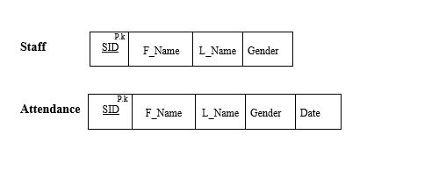 51](#_Toc510106130)

[Normalized Relational Schema 52](#_Toc510106131)

[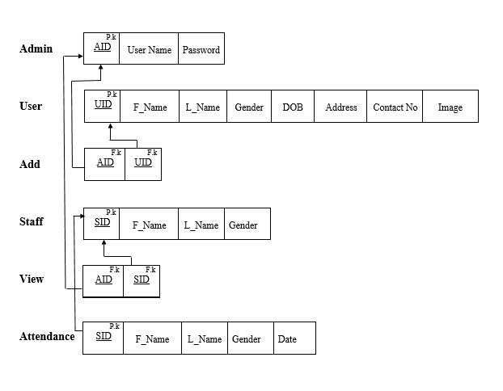 52](#_Toc510106132)

[Deliverables 53](#_Toc510106133)

[Time Plan for Implementation 54](#_Toc510106134)

[Conclusion 54](#_Toc510106135)

[References 55](#_Toc510106136)

# Abstract

The face is the main recognition of a Human being. The strategies to abuse this physical component have since an awesome change since the invent of picture recognition systems. The framework depicted in this paper means to digress from such customary framework and acquaint and new methodologies with recognize a staff face recognition framework.

Neural Networks have been used in order to develop this high technologized and secured face recognition system. In this system Artificial Intelligence has been used as following, first the individual will take five different pictures in different angles and the captured pictures will be transformed into grey-scale and stored under that person’s name. and then the images will be converted into 50% of its size in order to reduce the salt noise of the images and to reduce the flash effect to train the system using Neural networks. The images will get a smooth effect and reduced image information.

After the image process the standard image detecting algorithm in the system collects image features such as the person’s eyes, nose, hair, forehead, mouth chin and eyebrows and save the data to the database for the training.

This face recognition attendance system is implemented in the private company named Holborn assets located in Nawala for the real time testing purposes and as the conclusion of the testing we got a result of 15% failure to identify the exact person. This occurs when the person appears in a different appearance than the images in the database and the different light effects, and we had a decision of taking more images in the different lightings such as daytime natural lighting and in the night time lighting positions while training the system.

# Chapter 01

## Introduction

The face recognition system is a developed framework which is utilized by the entire universe for various purposes. This distinguishes a specific individual by the stored pictures as in categorizes how the individual looks like, so if his information is put away, he will be offered access to the framework in which he needs to get in addition to on the off chance that he isn't perceived by the framework, he won't be.

As I mentioned above as per the proposal for the final project, I have picked the topic as a face recognition system which recognizes person's face by the stored information which has been in the framework. The example taken further on this topic will be of the Holborn Assets situated in the Colombo. The framework which is utilized right now is a fingerprint system, in which there such a large number of things which could turn out unexpected, that likewise the unique finger impression frameworks are utilized just in the principle branch. Since this is the entire power leading group of Sri Lanka, there are such huge numbers of branches all throughout the nation. Furthermore, in alternate branches, they utilize a manual framework which is somewhat obsolete these days, and extremely hard to deal with. Concurring what the officers said there was, this framework currently is bit hard to deal with and furthermore even the IT division of the primary branch is proposing if it's a facial recognition framework is actualized for the participation, that would be considerably less demanding to compute their pay and constantly and all resemble caught precisely

As the introduction of the framework "Face recognition", these are for the most part utilized for security purposes in the early days, however now this is some least demanding way that have been utilized as a part of various sort of strategies. Nowadays for some portable instalments and airport security they utilize this framework, With regards to perceiving faces, it distinguishes a human face with 80 nodal focuses. It not only catches the face but also creates a unique technique with the nodal.

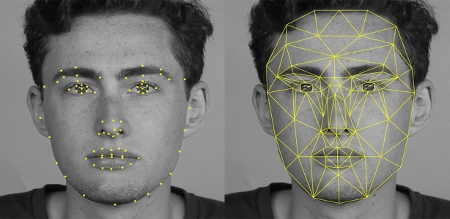

Figure

Like the above picture, that is the way the framework perceives the human face with nodal focuses. What the nodal point in actual does is for instance taking twins working in a similar organization in consideration. This utilizes to gauge the variable focuses, width of the parts that what confront contains, wrinkles, cheeks and so on. In simple it helps to identity that the person is in a form of digital images. In other countries as such the USA according to the CBS news, the country database uses this face recognition system so why not Sri Lanka brings about this?

## 1.1 Problem Statement

Up to date, the issue in the 21st century is, regardless we haven't proceeded onward to the present century from the past twentieth century. The pitiful truth is, just the created nations are taking points of interest of the most up to date advances which have been acquainted time to time, however the creating nations are really not which is unreasonable. What issue was recognized here is Holborn Assets needed to make their participation framework computerized. As of now what it has is, the primary branch, an eye discovery which is highly computerized when it’s contrasted with alternate frameworks we have in Sri Lanka. Be that as it may, alternate branches throughout the nation, a few have unique mark framework (fingerprint), and a few have a manual strategy, a mark framework which is so difficult to oversee and keep up. Indeed, even this is distinguished as an issue since the framework isn't robotized. Presently a long ways past that, the issue what has been recognized personally is, since the framework is manual, the staffs can simply give a signature and misuse it Yet, it doesn't mean the specific individual from the staff have to keep proof after use. Indeed, even his companion from a similar office can put his signatures without the individual being present there. Yet he will be distinguished as a man who sought work despite the fact that he truly didn't. In this way, my point is if ten staffs do this for a month in a specific branch, in like manner it will at any rate happen everywhere throughout the nation. So how many amounts of misfortune will the Sri Lankan government needs to confront? This is some significant issue. Like for an illustration, this even occurred in India years back, and afterwards they had thought of a similar arrangement, executing a computerized confront recognition framework, leading to an issue of money. When the framework is manual, they can attempt an indistinguishable thing from what I have said above, such as asking to keep the mark from another person, and they'll be considered in the event that they have worked additional time. Thus, they'll be paid more. A similar sort of misrepresentation will happen with regards of short leave or half day, the mark can be kept by another person, and the specific staff will be considered present as if he worked the entire day. Who needs to acknowledge the misfortune what occurs here? Certainly the administration. Along these lines, this has been distinguished as the issue in the Holborn Assets, there concocting an answer is an absolute necessity here.

## 1.2 Proposed Solution

Agreement to the issue explanation which have been expressed above Holborn Assets needs to change its participation framework which is currently present. At the point come to the equipment it won't cost them as much as the unique mark framework or some other mechanized frameworks would, excluding the Manual framework because it won't cost in any case when it’s contrasted with computerized frameworks. These frameworks help us to keep up the entire participation framework and keep it reason like exact. Additionally, what the innovation will be utilized here is "Neural Networks" which is a manmade brainpower philosophy from which every one of these procedures will be simple as what we have expected and what our customer "Holborn Assets" needed.

At a few focuses, individuals do even execute facial recognition framework and unique finger impression framework both in the associations. In any case, our customer is simply Holborn Assets, along these lines of participation framework which just perceives the face.

Since there resembles more than 50 individuals work in a specific branch in Colombo and in the close by regions, the different branches it relies upon the general population live in the specific zone, the proposed arrangement ought to be quick and exceptionally straightforward. This robotizes the staffs’ login times and their participation by the computerized reasoning strategy that we have actualized here. It catches every last representative's work hours and stores it to the back end. The administrators can arrange workers in the participation administration framework into a table format ordering with the staff and timings. It can make the entire organization forms a considerable measure less demanding.

In the last Its coding gives a report before the month is over, similar to a participation framework report with all the participation details as in the timings of their duration at work to what extent they have taken breaks every day, their working hours, in like manner it will be sifted by the way we ordered them and present the entire answer to the chief. This above is possible after the utilizing of the face recognition system that we will execute including the framework itself which will be basic as it clarified previously.

## 1.3 Literature Review

This is a research (Face Recognition) which is a main developing problem when it comes to train system with countless images. This is because facial recognition has some influence everywhere in the developed countries, regardless of any other system being used, facial recognition system will be with the concept of artificial intelligence. For instance, in order to prevent the frauds of ATM in India, it is recommended to prepare the database of all ATM customers with the banks in India & deployment of high resolution camera and face recognition software at all ATMs. Thereby whenever the user will enter in ATM his photograph will be taken to permit the access after it is being matched with the stored photo from the database. Where there is an ATM, a face recognition system is there. Similarly, extortion investigator framework which CBI utilizes as a part of the India, Security observing from the significant organizations, wherever there's a face recognition framework comes.

Presently the world begins to think about the components that made this face recognition system to develop. The significance, the impact and so forth this is on the grounds that the dynamic improvement of calculation, additionally we can get an extensive database just where there are such a large number of facial recognition computerized pictures. This counterfeit neural system strategy has the capacity of a human mind so distinguishing or perceiving a man's face.

A case in 1996, Rowley and group invented the face recognition system in view of a retinal associated neural system which analyzes little windows of a picture to choose whether every window contains a face in it. For this procedure, they have utilized a bootstrap calculation so as to take out troublesome errands of physically choosing preparing cases, yet not faces.

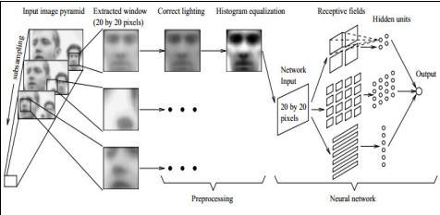

Figure

The above picture demonstrates their correct test, first time it was tried with a picture of a window. At that point the window went through neural system, where it begins to detect the window picture, a face. (**Rowley, 1999**)

Safe house International Limited, an Australian organization, protected programming including face recognition systems. The organization asserted this framework could track moving individuals and compute the quantity of individuals in a group. After 9/11, the product was considered "financially appealing" by the US organization. In like manner, what is told above is retinal associated neural system. At that point there's quick neural system. Neural systems technique to decrease the calculation time for finding human countenances. Each picture is isolated into little sub pictures and afterwards everyone is tried independently utilizing a quick ANN. The test aftereffects of examination with traditional neural systems demonstrated that the rapid is accomplished while applying FNN.

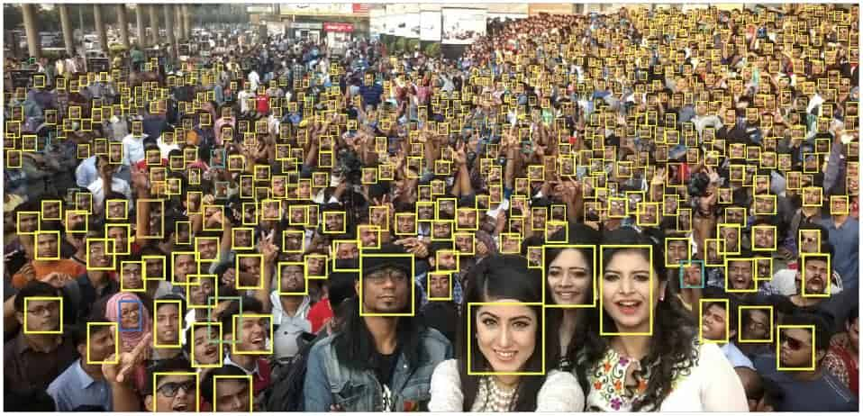

Figure

Then again, social medias, for the most part Facebook utilizes another innovation which is specified as "deep Face", when a user uploads a picture of him in facebook, a personal picture, or with a group of people, this way it effortlessly recognizes those individuals who are in the specific photograph so it will be convenient to tag those people who are in the other pictures.

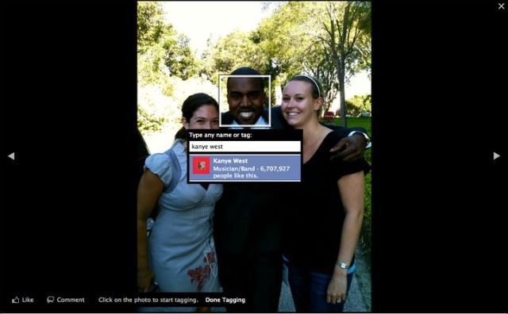

Above strategy was one of the AI techniques which I specified as Deep Face technique. The individual's Facebook ID comes directly after when the cursor is moved close to the face in the picture. Prior to these profound strategies were presented, web-based social networking applications were utilizing some unique sort of face recognition frameworks. With regards to social Medias, Facebook has seen very improved in this Deep Face method comparing to other social Medias. Indeed, even this additionally goes under the face recognition utilizing neural system.

As the facebook’s recent updates their face recognition works even better in the Facebook network. Such as finding photos the user is in but haven’t been tagged, help the user by strangers using their pictures and especially tell people with visual impairments who is in their photo or video. These features are quite interesting and useful for maintaining the user privacy.

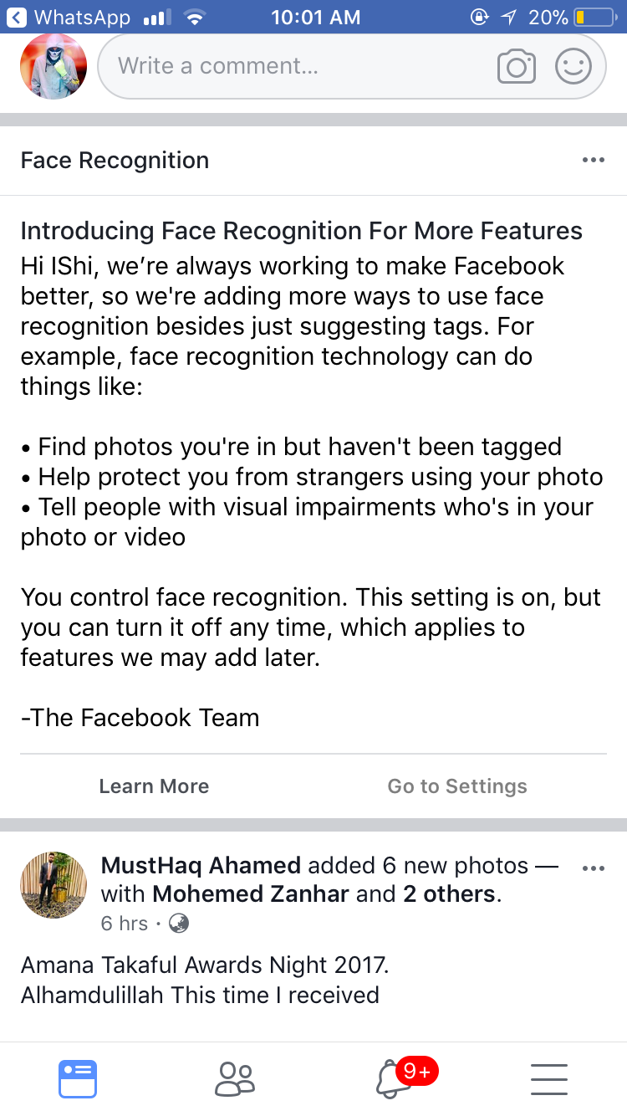

Figure

In 1999, Jeffrey Norris utilized the Principal Component Analysis (PCA) with class-particular direct projection to identify and perceive faces in a video stream progressively. Figure 5 indicates the Principal Component Analysis and ANN for the discovery of countenances. The framework sends requests to a programmed sliding entryway, to a voice synthesizer and to a touch screen through a various customer control server. MATLAB and Java were utilized to build up the framework. The framework searches for a face in a picture. (**Norris, 1999)**

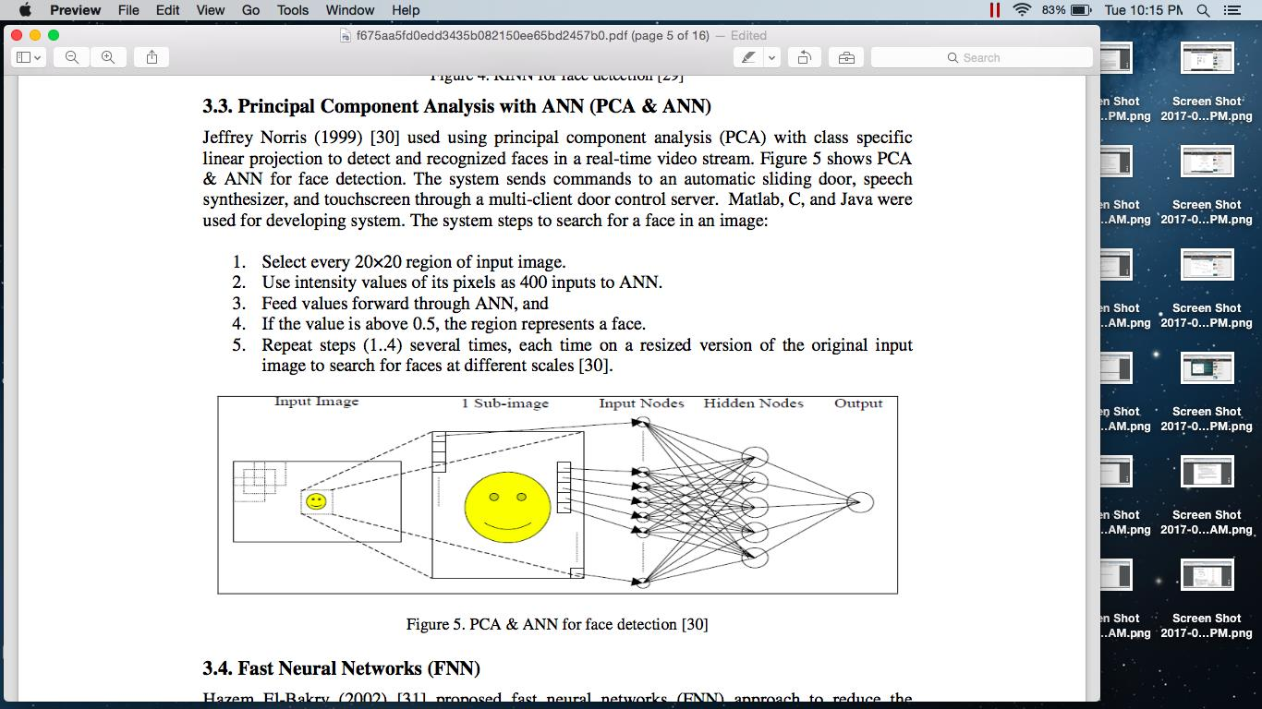

Figure

#### Convolutional neural networks (CNN)

We report on a series of experiments with convolutional neural networks (CNN) trained on top of pre-trained word vectors for sentence-level classification tasks. We show that a simple CNN with little hyper parameter tuning and static vectors achieves excellent results on multiple benchmarks. Learning task-specific vectors through fine-tuning offers further gains in performance. We additionally propose a simple modification to the architecture to allow for the use of both task-specific and static vectors. The CNN models discussed herein improve upon the state of the art on 4 out of 7 tasks, which include sentiment analysis and question classification. (**Yoon Kim,2014)**

## 1.4 Feasibility Study

This is something that investigators whether it's conceivable to execute the new framework as per the customer's prerequisite. In the event that it is acceptable, the proposed arrangement will be executed. If not, the creating group will locate an option or will quit making the following stride. To complete this report a few variables ought to be considered. Those are;

• Scope Feasibility

• Economic Feasibility

• Social Feasibility

### Technical Feasibility

This is the principal period of investigating a venture, the degree to which the framework can be effectively planned, created, and introduced by the IT gathering. In this first stage, the designers should confirm if they can conquer the snags that they have of building the framework and finish the entire framework as per customer's prerequisite.

So here when the creating group anticipates utilizing another innovation for the framework, risk increments intensely when the innovation itself is new. Task estimate is an imperative thought, regardless of whether estimated as the quantity of individuals on the improvement group, the period of time it will take to finish the undertaking or on the other hand the quantity of unmistakable highlights in the framework. Larger ventures display more hazard, since they are more confused to oversee and on the grounds that there is a more prominent shot that some critical framework necessities will be disregarded.

The degree to which the task is profoundly coordinated with different frameworks can cause issues, since intricacy is expanded when numerous frameworks must cooperate.

In the end, venture groups need to consider the similarity of the proposed arrangement with the innovation that officially connected on the present framework. New innovation and applications should have the capacity to coordinate with the current condition for some reasons. They may depend on information from existing frameworks, they may create information that nourishes different applications, and they may need to utilize the organization's current interchanges foundation.

### Scope Feasibility

The extension achievability chiefly focuses on the extent of the task. By directing this possibility, it gives a legitimate thought of how the undertaking will function, with a specific end goal to accomplish this task what are the things that must be taken after moreover heaps of thing will be shrouded in scope plausibility.

Likewise, this for the most part about the motivation behind the framework be made or a framework substitution by an old framework to new one simply like what occurs here. Old manual framework to new computerize confront recognition framework utilizing manmade brainpower methods.

### Time Feasibility

Time is Gold, as the precept says; things ought to be secured inside the due date which is allotted by the venture director. Since in this true, on the off chance that we aren't productive to our customers, we will be supplanted by one of our rivals.

A straightforward methodology of the market presently for this situation, our customer Holborn Assets is in a rush that they require a framework as quickly as time permits to supplant their old manual framework. In this manner, time plausibility ought to be directed here and complete the venture at the earliest opportunity and before the due date.

## 1.5 Design Overview

### Development Method

The strategy will be the most proper life cycle for the face participation framework as it is the simples and furthermore least expensive one. It is appropriate for the sort of programming for checking requires and will make things clear. It centers around the documentation, for example, prerequisites and outline additionally this module is exceptionally taught it has reasonable faces and does makes it all the more effectively justifiable for the client, waterfall module is referred to for that as it is utilized as an advancement case in numerous product's courses also.

Conclusion is that will utilize the waterfall model to make the product framework for the organization after the different procedures have been finished.

Because of inside advancement administration will change the exchange regularly in this way waterfall technique is prescribed to take after.

#### Choosing the appropriate programming process demonstrate for the proposed framework

After deliberately completing a progression of polls I have discovered what the framework ought to be incorporated

• The framework ought to have the capacity to keep going long

• The must meets its necessities productively

• Risk is limited

• Project can be finished inside a constrained time

• User in association is high

• User association needs to easy to understand

## 1.6 Work Breakdown Structure

1. Initiation

1. Feasibility investigation

2. Gathering data on proposed framework

3. Analysing of data

4. Conclusion of feasibility Study

5. Create scope

2. Establishment

1. Develop venture design

2. Define roles among the team

3. Verify and validate client requirements

3. Designing

1. Function design

2. Interface design

3. System design

4. Database design

5. Review the design

6. Design finalization

4. Development

1. Develop framework modules

2. Integrate framework modules

3. Perform beginning testing

5. Testing

1. Performance framework testing

2. Find the Document issues

3. Correcting the issues

4. Completion of the Testing

6. Implementation

1. Launch the framework

2. Present Final task

3. Project Completed

## 1.7 Resource allocation

This program has been developed using Matlab and mysql. I have used the latest version of matlab to develop this project. And also I have used libraries to make the application more functional. To run this application user will need the following specification requirements and software installed in order to run the system.

## 1.8 Milestone Plan



Figure

## 1.9 Cost Plan

### Webcam to capture the image

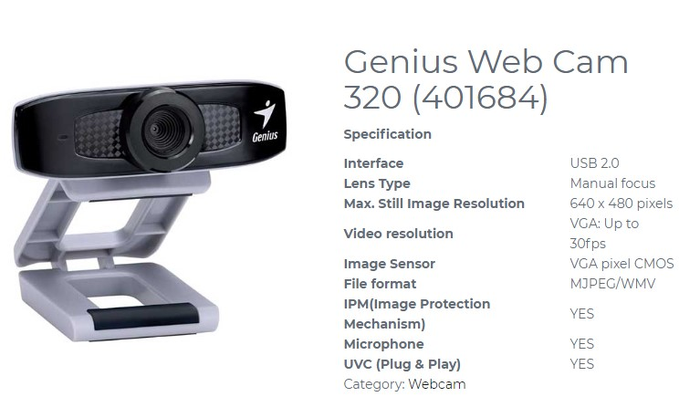

Figure

### Desktop Computer

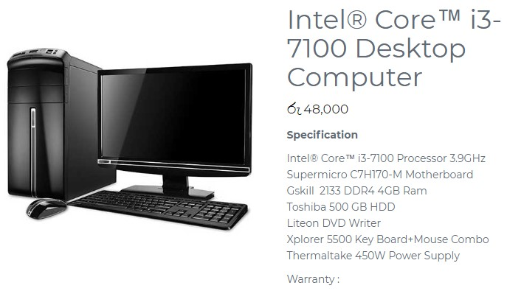

Figure

### Server

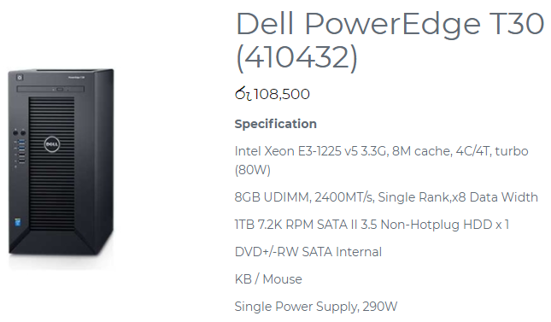

Figure

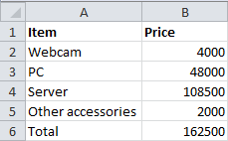

Figure

As the list above, to deploy the face recognition system in the company the company will have to spend the amount of 162,500/= for the hardware needs for this system.

### Resources Required

To manufacture and execute the present framework, I require a few applications to finish the entire undertaking. What's specified here is, for the documentation and the framework for the entire procedures and so on.

**MS Packages**

**MS Word 2016**

So as, to write entire content related archives, I need MS Word for the task. With regards to a building up a framework it's not just about building up the framework. Yet additionally, the documentations as well likewise assume a noteworthy part when creating frameworks. That is the manner by which a task finishes like generally speaking. So as to make the undertaking documentation flawless, I have picked MS Word when other programming likewise exists to type these documentations.

**MS Visio 2016**

This is from a similar bundle from Microsoft from which I needed MS Word; however the reason for utilizing the application is entirely unexpected. Microsoft Visio is utilized for creating bound together displaying dialect charts (UML Diagrams) we require Microsoft Visio to make our procedure simple. We have to create UML graphs, for example, utilize case outline, class chart and ER charts. These charts give individuals an appropriate thought that the procedure of the framework.

**MS Project 2016**

As I said above, time is gold. With a specific end goal to keep up the time administration, we require MS venture for our documentations. Likewise this is a task administration programming item, created and sold by Microsoft. It is intended to help an undertaking supervisor in building up an arrangement, doling out assets to assignments, following advancement, dealing with the financial plan, and dissecting workloads. Why we use here it is basically, dealing with the time.

**MATLAB**

This joins a work area condition tuned for iterative examination and configuration forms with a programming dialect that communicates framework and exhibit arithmetic straightforwardly. Likewise, this is the principle application we require with a specific end goal to build up the framework too. Also, this is a product which is being utilized for the most part for computerized reasoning purposes.

### Expected Output and Outcome

Expected yield are the outcomes which happens without even a moment's pause when the framework is actualized. Thus, as indicated by the arrangement that I recommend here, the normal yield will be the participation framework which won't be a wreck any longer. It would resemble a report created, simple as the way it’s depicted previously. The issue is, the point at which the framework is executed, a few challenges may occur since the staffs who aren't PC ignorant may think that it’s hard to utilize, yet directly after a workshop or an exhibition, similar to a preparation or a demo session, they may comprehend this as the structure that the framework is therefore means by which it will work.

Then again, what is the normal result? How it varies from expected yield? Expected results will be considered as mid-term comes about. These sorts of results won't be viewed when the framework is executed. This may set aside the opportunity to see the real outcomes. Be that as it may, at that point after now and again will have the capacity to see the progressions at the ground level due to the undertaking movement, and that is the place it is named as a result. At the point when the staffs tend to continue utilizing a similar application, without a doubt in a few months the framework will be executed everywhere throughout the Sri Lanka. Furthermore it can make an entire insurgency island wide in robotized frameworks where alternate associations additionally may take after.

# Chapter 2 Background of the Study

As indicated by the reviewing the vast majority of the present framework has been discovered that, the present semi-automated framework isn't anything but difficult to utilize. Since numerous apparatuses must be done physically and the frameworks utilized for various errand are not interconnected, they are confronting issues keeping up the information and furthermore squandering loads of significant time.

## 2.1 What is it?

Innovation has been affecting our lives every day for quite a while in light of the fact that it spares people time and labor. Along these lines, if Holborn Assets LTD has swapped their current manual framework with this proposed arrangement, it certainly will help their business successfully.

Holborn Assets LTD is a private company in Sri Lanka. Staff rate and their personality among staffs are hugely going high. Thus, the new framework will give our customers to enhance their administration of workload fulfilling the clients in the interim it'll prompt help find alluring new clients.

Their primary necessity was to get to their regularly developing workload quicker and making it simpler to enter subtle elements of their developing clients on a dependable database from which information can be put away and recuperated whenever they need without the need to experience abundant of records physically. Likewise, their dread was security and data protection.

## 2.2.Why is it Important?

From the manual framework, our customers are moving to a robotized framework, since they are inadequate with regards to something in their current framework. In this way, they would feel the significance of this proposed arrangement. The motivations behind why this proposed arrangement is so critical to the healing center are taken after:

• Inconveniences happen when information process – the manual framework takes much time. In spite of the fact that there are numerous staffs work there, customers feel it will be speedier in the event that it occurs through machines. Since human commits errors when machines doesn't.

• Security and data protection – since workers and staffs and the clients have been given diverse client parts with the goal that will make the security more quality. There are one client parts in the proposed arrangement. So at whatever point they enter their correct client id and secret key, they will have the capacity to get to the framework. Furthermore, the capacities are restricted to client to client who utilizes the framework.

• User friendly – the general population who and staffs who will utilize the framework needn't bother with any additional information to utilize the proposed arrangement. A straightforward learning which everybody has, to work a PC is all that anyone could need.

## 2.3. List of User Requirements

I have gathered some client requirements when I was directing the user requirement specification. Moreover, the client requires are these:

• They require a framework with client parts – this is something that they solicit to guarantee their security from their site. When they have distinctive client parts so as to sign in, they are permitted to get to the capacities just which are permitted to them.

• User Manual – the framework might be exceptionally easy to understand yet at the same time the customers have questions about the framework what they will use since it's something new. Along these lines, a user manual is an unquestionable requirement to the customers.

• A framework that point out errors – our customers required this thing since people commit errors when they work something. In this manner, when the client who works the framework commits an error, he ought to be advised that he made something incorrectly. Illustration, when the client enrolling himself, and he abandons one field purge. That is the place the client ought to be advised.

## 2.4. The Current System

The Holborn Assets LTD load up utilizes the manual framework right now, which includes entering all the in and out time subtle elements on a book which will be gotten to and handled later. This includes recording every single data when an exchange happens. Every one of the procedures like from the staff get a leave, and until the point that the he's finished with that leave everything is done physically by the administration.

For administrator, administration will keep a different book. In that they will store data like their participation, leave subtle elements and so on if another staff has joined the Board, another document will be opened for him likewise and it will be kept up as indicated by his works. Like how the system goes.

More often than not, these archives won't have reinforcement for crisis. Every one of these archives is put away in a storage space which will dependably be bolted unless fundamental. In spite of the fact that this sounds more secure, it will take hours and at some point days to search for a data in the event that if something turns out wrong.

## 2.5. Drawbacks of the Current System

• Lack of Security – administrator and staff data are kept in a room; everybody can get to those since everybody is permitted. there are no client id or secret word since this is a manual framework.

• Lack of Time – For some situation, in the event that anything turns out badly, when they need to look through a different staff record, it isn't so much that simple to seek among a large number of data.

• No reinforcements – if it's a PC framework, we can in any case keep reinforcement. In the event that something occurs there are chances that entire data will be devastated.

• Entering Information - Entering records now and then is a genuine issue where if a minor oversight is recorded according to human carelessness, the outcomes can be serious and looking for the particular data and refreshing them isn't that simple.

## 2.6. Explanation of the Proposed System

This is an electronic framework which will store staff data from manual to robotized frameworks. Thinking about every one of these certainties, this computerized framework for the Holborn Assets Ltd which can enter staff participation moreover it monitors past record.

When you contrast the proposed arrangement and the old manual framework, it's exceptionally cheap, compelling and has no extra costs.

The proposed arrangement will be produced like; it will be associated with the database which is the backend of our framework. And furthermore, the current proposed arrangement can be utilized by any division to supplant their current manual paper based framework. The new framework will control data like staff participation data, ward accessibility, staff and working room plan. Every one of these administrations will be furnished in a powerful way with the objective of lessening the time and recourses.

# Chapter 3 Feasibility Study and Requirement Gathering

## 3.1 Feasibility Study

Feasibility study is studying the client’s requirements and analyzing weather it is possible to develop and implement according to client’s requirements. If it is feasible the proposed solution will be implemented and If it is not feasible the project will be stopped or find another alternative feasible solution. Following studies should be done to complete the feasibility study:

* Cost Feasibility
* Time Feasibility
* Scope Feasibility
* Technical Feasibility

### 3.1.1 Cost Feasibility

This project is going to have 5 financial years and one financial year consider as 3 months. The cash inflow of 1st year Rs0. From 2nd to 5th year project will receive Rs.12000 as the cash inflow. In the 1st year cash outflow is Rs.3000 and in other years will have Rs.1000 of cash outflow. Discount rate 12%.

### Calculating Net profit value

|  |  |  |  |  |  |
| --- | --- | --- | --- | --- | --- |
|  | FYO | FY1 | FY2 | FY3 | FY4 |
| CIF | Rs.0 | Rs.12000 | Rs.12000 | Rs.12000 | Rs.12000 |
| COF | Rs.3000 | Rs.1000 | Rs.1000 | Rs.1000 | Rs.1000 |
| CF | -3000 | 11000 | 11000 | 11000 | 11000 |

Table Net profit value

Pv0 = -3000 / (1+0.12)0

= -3000

Pv1 = -11000 / (1+0.12)1

= 9821.42

Pv2= -11000 / (1+0.12)2

= 8769.13

Pv3= -11000 / (1+0.12)3

= 7829.58

Pv4= -11000 / (1+0.12)4

= 6990.69

NPV= -3000+9821.42

+8769.13+7829.58+6990.69

30410.82

The NPV is positive which mean the project can be undertaken.

### Calculating return on Investment

|  |  |  |  |  |  |
| --- | --- | --- | --- | --- | --- |
|  | FYO | FY1 | FY2 | FY3 | FY4 |
| Benefits | Rs.0 | Rs.12000 | Rs.12000 | Rs.12000 | Rs.12000 |
| Cost | Rs.3000 | Rs.1000 | Rs.1000 | Rs.1000 | Rs.1000 |
| DF | **1** | **0.89** | **0.79** | **0.71** | **0.63** |
| DB | **0** | **10680** | **9480** | **8520** | **7560** |
| DC | **3000** | **890** | **790** | **710** | **630** |

Table return on Investment

DF FY0 = 1 / (1+0.12)0  DB FY0 = 0\*1

= 1 = 0.89

DF FY1 = 1 / (1+0.12)1  DB FY1 = 12000\*0.89

= 0.89 =10680

DF FY2= 1 / (1+0.12)2 DB FY2 = 12000\*0.79

= 0.79 = 9480

DF FY3 = 1 / (1+0.12)3  DB FY3 = 12000\*0.71

= 0.71 =8520

DF FY4 = 1 / (1+0.12)4 DB FY4 = 12000\*0.63

= 0.63 =7560

DC FY0 = 3000\*1

= 3000

DC FY1 = 1000\*0.89

= 890

DC FY2 = 1000\*0.79

= 790

DC FY3 = 1000\*0.71

= 710

DC FY4 = 1000\*0.63

= 630

ROI = (((0+10680+9480+8520+7560) -(3000-890-790-630)) \*100) / (3000+890+790+710+630)

= (((36240) -(6020)) \*100) / (6020)

= ((30220) \*100) / (6020)

= 3022000 / 6020

= 501.9%

ROI value is containing a higher rate so this project will be a successful project.

### Calculating playback period

PBP =3000/12000

= 0.25

According to the calculation of this project will recover the invest money on the first year. So this will be the better project to work on.

### 3.1.2 Time Feasibility

This is most important that to dissect the time Feasibility to complete the full Project and implement it. Below month we required to execute new arrangement of face recognition system has chosen to process the undertaking on 18th of January 2018 and Implement the system on 10th of April 2018.

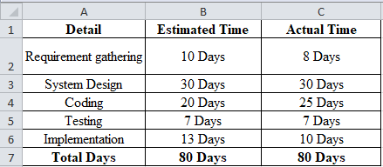

Figure

As the above list of estimated time and actual time spent the time period which is actually spent is equal to the time period which is estimated. So this project is time feasible.

### 3.1.3 Scope Feasibility

The Feasibility study mainly focuses on the extent of the task. By directing this feasibility study, it gives a legitimate thought of how the undertaking will function, with a specific end goal to accomplish this task what are the things that must be taken after moreover heaps of thing will be shrouded in scope feasibility.

Likewise, this for the most part about the motivation behind the framework be made or a framework substitution by an old framework to new one simply like what occurs here. Old manual framework to new computerize face recognition framework utilizing manmade brainpower methods.

### 3.1.4 Technical Feasibility

This is the main period of breaking down a task, the degree to which the framework can be effectively composed, created, and introduced by the IT gathering. In this first stage, the designers should make sense of whether they can beat the hindrances they have of building the framework and finish the entire framework as per customer's necessity.

So here, when the creating group anticipates utilizing another innovation for the framework, Risk increments strongly when the innovation itself is new. Undertaking size is a critical thought, regardless of whether estimated as the quantity of individuals on the improvement group, the period of time it will take to finish the venture. or on the other hand the quantity of particular highlights in the framework.

Bigger undertakings introduce more hazard, since they are more convoluted to oversee and in light of the fact that there is a more noteworthy shot that some essential framework necessities will be neglected.

The degree to which the undertaking is very coordinated with different frameworks can cause issues, since multifaceted nature is expanded when numerous frameworks must cooperate.

## 3.2 Requirement Gathering

This is a strategy which directed by the framework experts to find that what sort of framework that the customer anticipates. There are some approaches to discover those, and these are called as truth discovering procedures. The analyst will pick one technology and counsel the end user.

The engineers and the customers both should consider the framework on the grounds that another arrangement is proposed due to conquer the issue they as of now have in the current framework. There for there are a few qualities for finding the reasonable certainty gathering strategies. Those are:

• Accuracy – The framework what is created should be error free.

• Satisfaction – The framework ought to fulfill the customers by finishing their requirements they specified.

• Completed – The framework ought to be finished inside the given time period without errors.

• Reliable – This is the designer's obligation to ensure the customers that framework will diminish a considerable measure work stack, in addition to it is more dependable than the current framework they are using.

• Efficient – the framework should work quicker, without getting stuck using the entire hardware requirements specified.

## Questionnaire

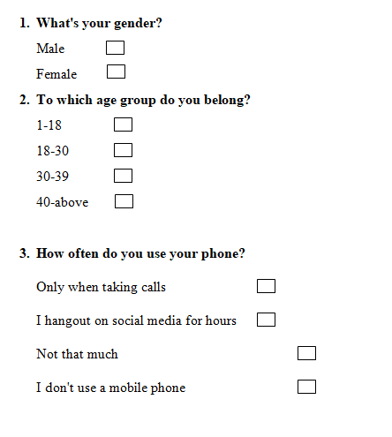

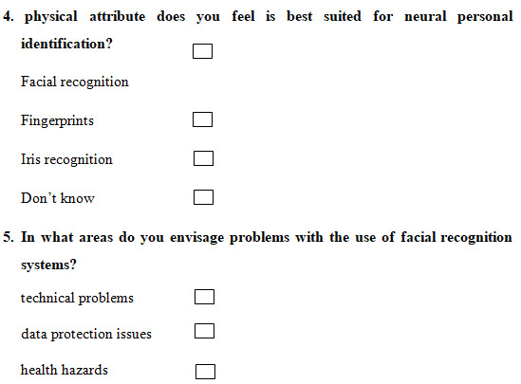

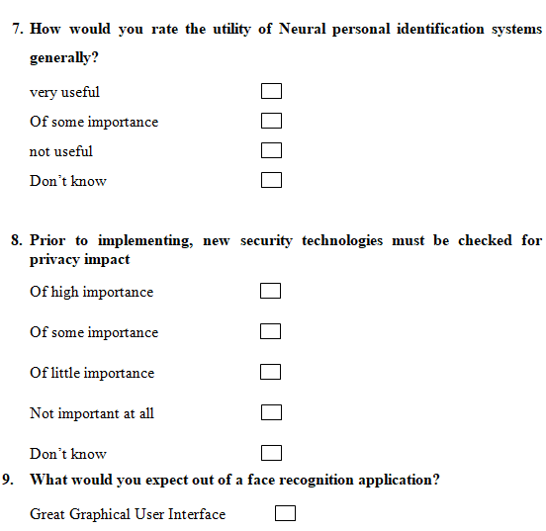

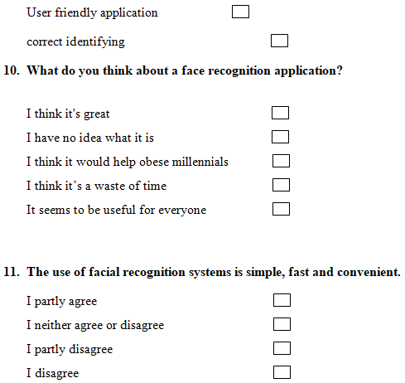

 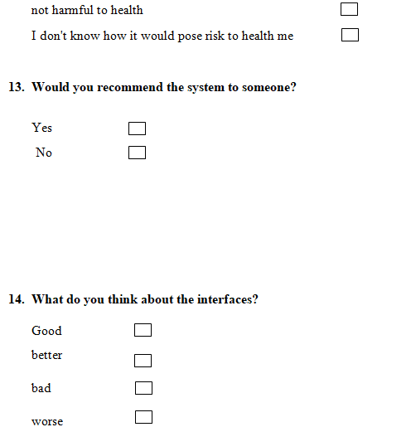

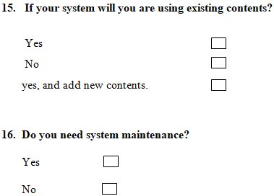

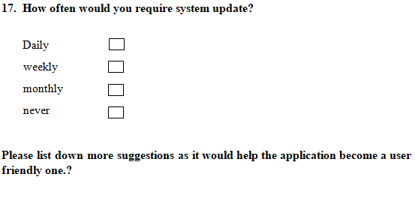

The above are the questions which were given to the users who are going to use the system.

## 3.3. The Software Process Model

This is a module which will be utilized as a part of project management. It shows the stages engaged with an information system development projects. as of late a few modules have been consolidated into a type of hybrid technology.

### Waterfall Model

The waterfall model, as discussed, characterizes a strict, resolute process for the development of programming. Because of the experimental nature of this project, such strict process may not be perfect. In the event that it turns out to be evident that the fathoming some portion of the framework requires a more radiation intelligent model, at that point the consistent model should be re plan. Nonetheless, this impractical since the plan confront has effectively occurred. The stages characterize in the waterfall show give a "premise" in which and iterative, liquid approach might be embraced. Amid first stage: "framework building", a structure for the framework is characterized.

### Stages of waterfall model

Requirement Gathering: All conceivable records will be accumulated which will be developed.

System Design: The things will be contemplated in this stage which we assembled in the past stage, and the framework configuration will be readied. In addition, it determines equipment and the framework necessities and characterizes framework engineering.

Implementation: The framework is created in little projects called units with the contributions of past stage. Each unit will be created and tested for its specific features.

Testing: The units which are created in the previous stage will be consolidated into a framework in the wake of testing every unit. And afterward the coordination will be presented on the whole framework which was tested for errors and failures. Deployment: The system will be discharged in the client condition once the functional and non-functional testing is finished.

Maintenance: There will a few issues in the customer division too. In such cases the group needs to investigate and take care of the issue for consumer satisfaction. (Debugging)

#### Advantages of Waterfall Model

• Easy to utilize

• Stages are all around characterized and points of reference are surely knew

• Provides a structure for the staff

#### Disadvantages of Waterfall Model

• All necessities ought to be known without a moment's delay

• Implementing changes will cost high and troublesome.

• Identifying and settling the issue is hard.

• Customers can't see the framework until the point when it's finished.

The technique will be the most suitable life cycle for the face recognition framework as it is the simples and furthermore least expensive one. It is appropriate for the kind of programming for observing requires and will make things clear. It focused around the documentation, for example, requirements and design plan additionally this module is exceptionally trained it has logical faces and does makes it all the more effectively reasonable for the client, waterfall module is referred to for that as it is utilized as an advancement case in numerous product's courses too.

# Chapter 04 Domain Investigation

## 4.1 Decision Support Tools

These apparatuses are utilized to help associations to take powerful choices. This is an extensive variety of PC based devices which is created to help choice examination and participatory procedures. A DSS comprises of a database, diverse coupled hydrodynamic and financial models and is given a devoted interface keeping in mind the end goal to be specifically and all the more effortlessly available by non-experts. This has a particular reproduction and forecast capacities but on the other hand are utilized as a vehicle of correspondence, preparing and experimentation. There are three parts accessible in choice help devices. Those are;

• Models

• User Interface

• Geographical Information System

### 4.1.1 Decision Theory

Choice hypothesis means a summed up way to deal with basic leadership. This basically permits the individual who will settle on the choice when he has numerous elective choices to pick. Besides, this recognizes a strategy predictable with some monetary and mental wants of the individual who will settle on the choice.

From taken Images framework dataset will have isolated into two sections

• Training

• Testing

We utilize 3 pictures from every envelope for preparing and the rest 3 pictures for testing. SVD, is connected to remove highlights from the pictures and HMM to assemble an acknowledgment confront.

Well is prepared with half of the face pictures and tried with another face picture not utilized for preparing. The model returns probabilities of how likely the inconspicuous face picture resembles every single one of the pictures utilized for preparing.

Keeping in mind the end goal to lessen the computational many-sided quality and memory utilization and enhance the speed of calculation we propose a viable picture pre-preparing. To start with, every client will take 5 pictures in various blessed messengers and spared under client name envelope each face picture is changed Ito a dim scale picture. (just for nabbed pictures). While prepare the framework each picture will change over into resize to around half of its size, such initially the pictures have 112\* 92 and incognito to 56\*46. As second above and beyond to that, keeping in mind the end goal to repay the blaze impact and diminish the salt commotion, nonlinear least request static channel abused (work oredfilt 2 in tangle lab). The channel has a smoothing part and diminishes the picture data.

### 4.1.2 Decision Tree

### 

Figure

## Specialized Tree

This is additionally a choice help apparatuses where individuals use to clarify through tree compose charts. This incorporates of choices and their conceivable results, including chance occasion results, asset expenses, and utility. this Commonly utilized as a part of tasks examine, particularly in choice investigation, to help distinguish a procedure destined to achieve an objective. Another utilization is as a spellbinding means for ascertaining restrictive probabilities. Also, it enables individuals to decay a vast complex choice issue into a few littler issues. It comprises three modules:

• Decision nods

• Chance nods

• End nods

## 4.2 Technical Research

This venture incorporates the plan of PC programming which entering records of staffs for a specific office with the point or motivation behind survey them later required for security and business purposes later on. In this way, the innovation is utilized as a part of given alongside its advantages.

### Technology

From taken Images framework dataset will have separated into two sections

• Training

• Testing

We utilize 5 pictures from every organizer for preparing and the rest 5 pictures for testing. SVD, is connected to extricate highlights from the pictures and HMM to construct an acknowledgment confront.

Gee is prepared with half of the face pictures and tried with another face picture not utilized for preparing. The model returns probabilities of how likely the inconspicuous face picture resembles every single one of the pictures utilized for preparing.

Keeping in mind the end goal to diminish the computational unpredictability and memory utilization and enhance the speed of calculation we propose a successful picture pre-preparing. In the first place, every client will take 5 pictures in various heavenly attendants and spared under client name envelope each face picture is changed Ito a dark scale picture. (just for captured pictures). While prepare the framework each picture will change over into resize to around half of its size, such initially the pictures have 112\* 92 and incognito to 56\*46. As second above and beyond to that, with a specific end goal to repay the glimmer impact and diminish the salt commotion, nonlinear least request static channel abused (work oredfilt 2 in tangle lab). The channel has a smoothing part and lessens the picture data.

## Result Accuracy

In here we executed this framework we are greatly worried on expanding exactness of the framework by anticipating unapproved gets to.

We utilized Mat lab HMM show which is a cross stage .Net wrapper to the neural system picture handling library. It permits HMM capacity to be called from tangle lab perfect dialects. It is quick, and it just needs a little measure of memory. And furthermore its permits utilizing picture class with dim shading and profundity and hereditary activities on picture pixels which increment the precision of the framework.

# Chapter 5- Project Infrastructure

The following are the infrastructures used in face recognition attendance system

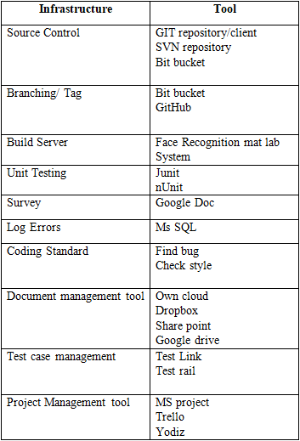

# Design

## 6.1. Design Overview

Face detection is fundamental front end for a face Recognition framework. Face detection finds and fragments confront locales from jumbled pictures, either got from still picture. The assignment of face recognition is apparently unimportant for the human brain. The human face changes as for interior variables like outward appearance and it is likewise influenced by outer elements like scale, conditions and introduction of face.

Face recognition framework is a tuff picture processing issue in real world applications with complex impacts of brightening and imaging condition on the live pictures. It is a blend of face detecting and recognition in picture analysis.

• Detection application is utilized to discover position of the countenances in a given picture

• Recognition calculation is utilized to characterize given pictures with known organized properties, which are utilized normally.

These picture have some known properties like; same determination, including same facial element segments, and comparative eye arrangement. These pictures will be alluded as "standard picture" later on areas. Acknowledgment applications utilizes standard pictures and identification calculations distinguish the appearances and concentrate confront extricate confront pictures which incorporate hair, temple, eyes, nose, mouth, underneath mouth.

The individual related will outline all the UIs while distinguishing all the essential yields, info, and procedures confront acknowledgment participation System. The applications engineering is additionally figured out which discloses the developers how to change the coherent plan into programming modules and codes. The plan has two phases:

## Architecture Diagram

## 

Figure

## Use Case Diagram

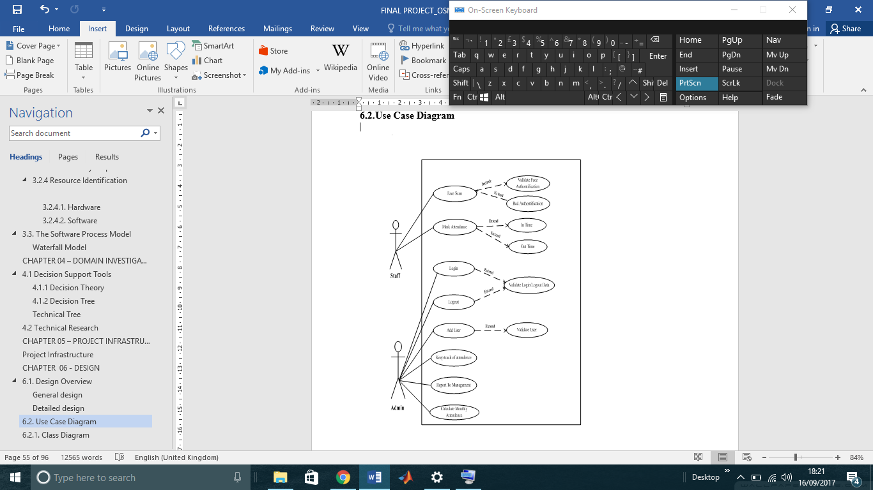

Figure

## Class Diagram



Figure

## Sequence Diagram



Figure

## Context Diagram



Figure

## Context Diagram (DFD)

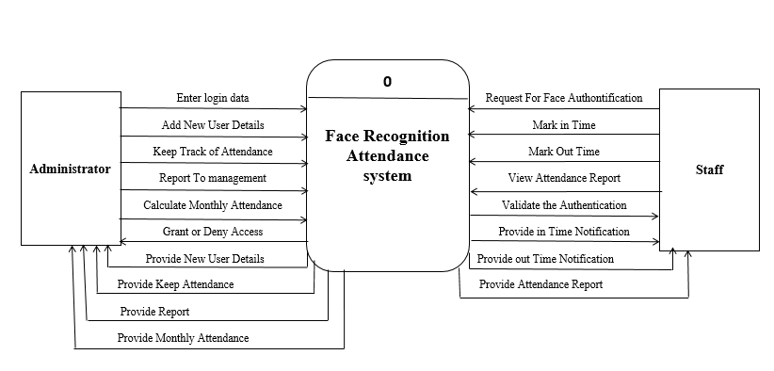

Figure

## ER Diagram



Figure

### Regular Entity

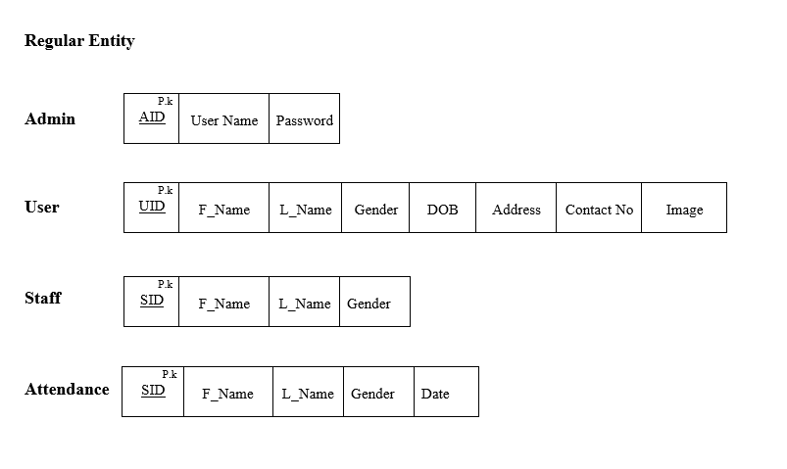

Figure

### 1:M Relationship

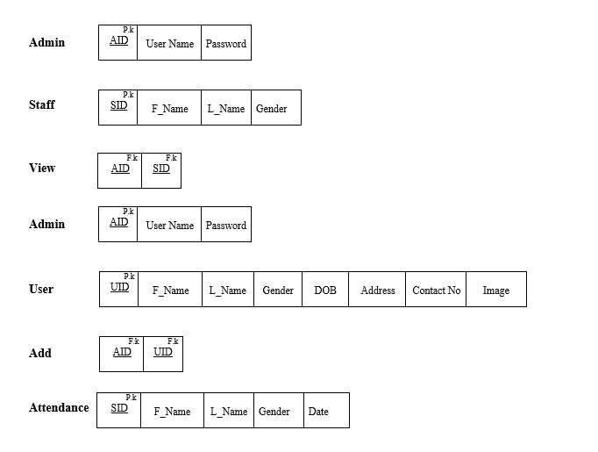

Figure

### M:M Relationship

### C:\Users\MacBook Air\AppData\Local\Microsoft\Windows\INetCache\Content.Word\M_M.PNG

Figure

### Normalized Relational Schema

### C:\Users\MacBook Air\AppData\Local\Microsoft\Windows\INetCache\Content.Word\finalization.png

Figure

### Deliverables

In this part, I was solicited to portray the yield from the task. These will incorporate the outcomes, any antiquity, or a detail investigation of the subject. The outcome what we will arrive is, as I said from the above undertakings, this is where heaps of individuals work in Sri Lanka everywhere throughout the nation, we anticipate that the arrangement will be quick, straightforward and the most effective one as all expect how a framework should function.

What we expect as a yield from the task may be, the framework ought to enable the specific staff to go into the workplace additionally the time that they're signing into the framework which helps the organization human asset administration to ascertain that to what extent that they have been working for the day, so the amount they have ought to be paid for the month if the compensation giving strategy is month to month premise, in like manner we can expect such a large number of yield from the venture.

Despite the fact that there are numerous frameworks accessible in the market which perceives the specific individual and gives him access to something, how this framework ends up noticeably one of a kind is the procedure that have been utilized here, the Neural Network. It takes in itself from the information we give and perceives this is who the individual is as per the framework that I will configure, underneath pictures are the data sources that I give, and the framework itself learns and perceive the individual and permits him.

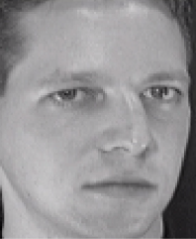

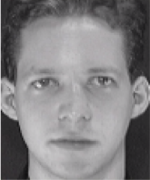

## Time Plan for Implementation

## Conclusion

This proposition incorporates everything about the recommended arrangements – Automated face recognition participation framework for Holborn Assets utilizing ANN (Artificial Neural Network). Since the Holborn Assets has a manual participation framework, I have addressed a staff Mr Dinuka, who works at a branch at Nawala. He expressed that lone the fundamental branch which is in Colombo fortification has the mechanized participation framework utilizing unique finger impression hardware, however not alternate branches. This is a noteworthy issue which the entire Sri Lankan government has been confronting, in light of the fact that there even are staffs that simply keep their mark and stamp the time that they have gone to the workplace as they need which appears to be so negative. Along these lines, we thought of an answer that this framework even notes the time that when the staff has gone to the workplace and the time that when he clears out.

In addition, the normal results and yields have been completely portrayed. The present circumstance of the participation arrangement of Holborn Assets, which is recognized as an issue thereby we should give an answer, so even an answer additionally, has been recommended. What's more, practicalities which is additionally a spine of the undertaking support and how it ought to be finished everything is all around clarified. At last, with regards to the framework, the database will be reached out as the staffs sum be that as it may; the framework makes the procedure simple

## References

Face recognition using neural network. 2017. *Face recognition using neural network.* [ONLINE] Available at: <http://neuroph.sourceforge.net/tutorials/FaceRecognition/FaceRecognitionUsingNeuralNetwork.html>. [Accessed 02 Feb 2018].

Funds for NGOs. 2017. *What is the difference between outputs and outcomes? - Funds for NGOs*. [ONLINE] Available at: <https://www.fundsforngos.org/free-resources-for-ngos/defining-project-results-proposal-difference-outputs-outcomes/>. [Accessed 03 Feb 2018].

Face recognition using artificial neural network. 2017. *Face recognition using artificial neural network*. [ONLINE] Available at: <https://www.slideshare.net/sumeetsumit/face-recognition-using-artificial-neural-network>. [Accessed 03 Feb 2018].

IEEE Spectrum: Technology, Engineering, and Science News. 2017. *Facebook’s Face Recognition Tech Goes on Trial - IEEE Spectrum*. [ONLINE] Available at: <http://spectrum.ieee.org/biomedical/imaging/facebooks-face-recognition-tech-goes-on-trial>. [Accessed 04 Mar 2018].

Convolutional Neural Networks for Sentence Classification [ONLINE] Available at: <https://arxiv.org/abs/1408.5882> [Accessed 23 Mar 2018]